Complex System brief

By Liam Gates

Contents

Complex System Summary – 1

Purpose of the Complex System – 2

Minimum Requirements – 2

Design Scope – 2

Feature List – 2

UML Diagram – 3

Risks and Concerns – 4

External Library’s – 4

Resources and References – 4

Summary:

The Complex Game System that I will be making is a Genetic Algorithm that you will be able to move from project to project. This system will be kept as transferable source code, so you will be able view it if needed and understand it to be able to fix any bugs that may be a result of not correctly applying the Algorithm to the function you are using.

Purpose of the System:

The test application will be a maze with the entity’s objective being to get from point A to point B. The fitness score will be how far it got to point B and in how short a time it managed to get there. More functionality and fitness score requirements may be added during the project to make it more appealing or to show off the GA more.

Minimum Successful Completion:

To create a genetic algorithm that can go from point A to point B in the shortest possible distance.

Design Scope:

I will be focusing on getting basic features done such as the GA and the basic point A to point B maze. If there is time left, I will attempt add any other features to the test Application that I have come up with during the project itself. The maze itself will be made prior to running the application and may be edited prior as well, but it will not be randomly generated during the running of the application.

Feature List:

* Accurate genetic algorithm
* Editable gene size
* Customizable maze
* Default or Custom point a to b
* Able to be moved into other projects

UML:

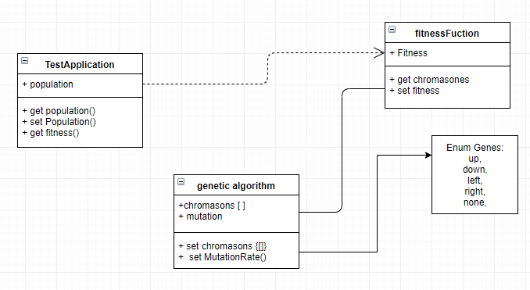

Risks and Concerns:

Some of the risks is that not all the minimum completion requirements don’t finish on time or that there are unforeseen problems with the genetic algorithm such as a problem moving it to other projects or with the source code for the GA it’s self

External Library’s:

* AIE-Bootstrap
* glfw
* glm
* imgui
* stb

these may be added to or removed during the project if needed

Resources and Reference:

* AIE slideshow
* <https://towardsdatascience.com/introduction-to-genetic-algorithms-including-example-code-e396e98d8bf3>
* <https://stackoverflow.com/questions/1538235/what-are-good-examples-of-genetic-algorithms-genetic-programming-solutions>